Lab POE: PL3

Name: Sayali Bothe

PRN: 22110053

Question 13

Website to display greatest people and was instructed to display the information of 3 people

Moreover, was asked to do the login and signup for the same.

Output:

Welcome page:



Login form:

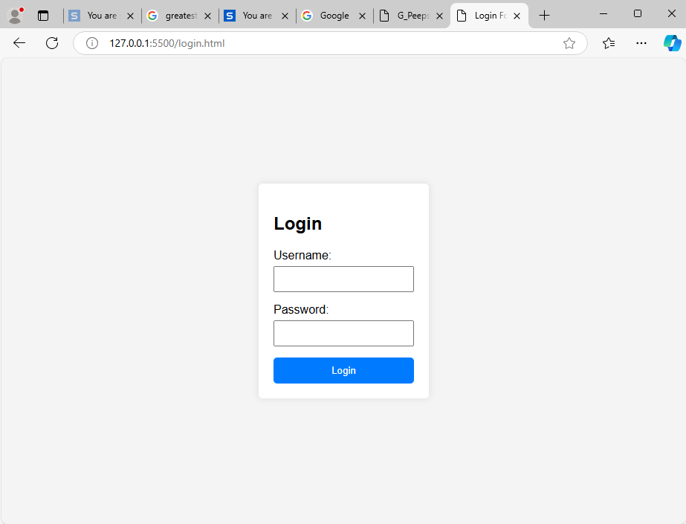

Signup:

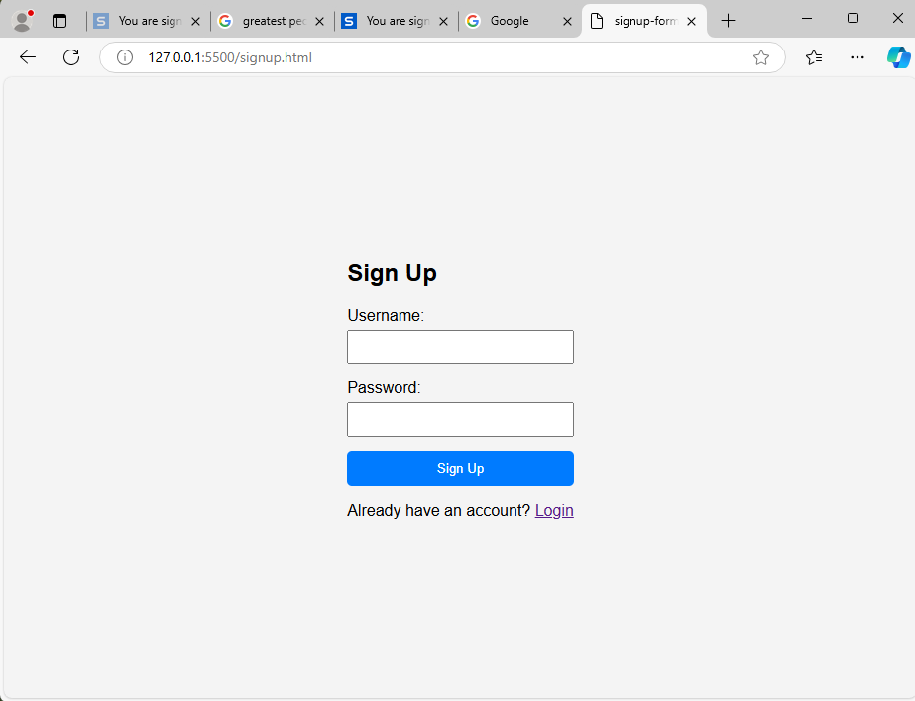

Home page:

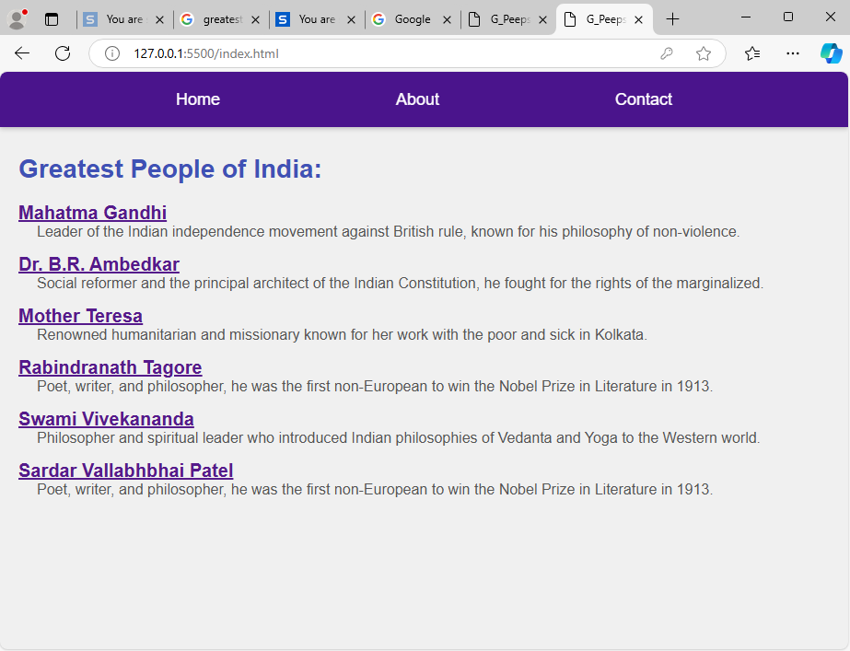

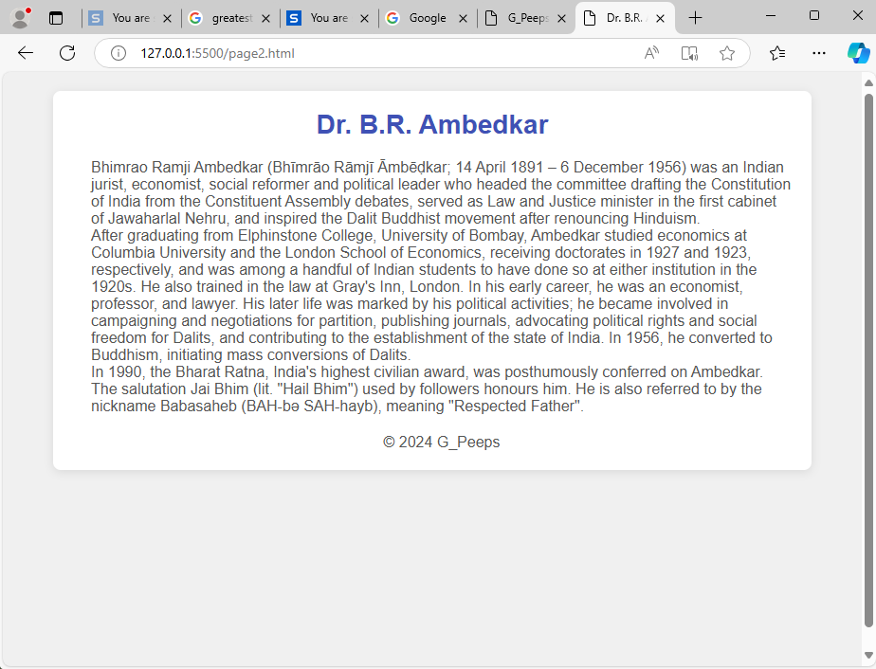

About and Contact:

